Other On-Call Numbers
Security:
2444 (HQ): 602-864-4464

DXC On-call:
Primary 602-723-6418 – POC

EBT: 480-415-6357
MetaVance/SI-5 Missing Files: 602-723-6394
TPS Cycle / Tertiary: 602-757-0136 (regarding VAT file/ TPS /txndata file)

Manager on-call:

602-318-0775, Kelly Royer, Finance
602-740-1014, Pat Daly

PlanConnexion On-call (Chicago, IL) (related: Association, Blue2, SI5):
Support 312-297-5500/6116 or 800-789-0051.
1 – Association technical support.
2 – Plan support (PX = ITS Files)
3 – Blue distinction center support

BES Operations (Pontiac, MI):
24/7 866-214-0108 press 1, 1, 1

Iron Mountain: 1-888-365-4766
User information needed when calling- Account number (DP####) and Authorization number (6 digit number)
Customer Care Email: request@ironmountain.com
Technical Support Phone: (800) 934‐3453
Technical Support Email: imosdpsupport@ironmountain.com

Convergys – Orlando (solarwinds alerts regarding switch - INC0069889)

POC is Edward Laskowski (407-771-6781 and ed.laskowski@convergys.com) for any routine day-to-day items such as any scheduled IT changes or any other non-emergency items.

For any immediate or emergency issues the Convergys Service Desk (CSD) is operational 24x7x365 and should be the point of contact. The CSD agents are non-technical but they can open a trouble ticket for your issue and begin the resolution process. If the issue is an emergency I would advise that when speaking to the CSD agent you request to be transferred to Situation Management (SitMan). SitMan is also a 24x7x365 shop and SitMan staff are technical folks and can page out the appropriate on-call technicians to support resolution of an issue. The CSD phone number is 888-578-3333 / Convergys Orlando Operations. (407) 771-8539.
Service Desk
Liz Baldwin / Autumn Oberlander
Liz Baldwin desk: (602) 864-7865 cell: (602) 721-2404 for all urgent matters. For all non-urgent matters create a SN ticket and assign to service desk and send Kim an email with the incident number included.

Nurse on-call
-Phone rotation (need pin number)
-ADOA line. Line transfer over after 6:00pm to the voice mail mailbox (citrix hub)
-make sure they using citrix hub not the old secure mail.
-Need reset pin – Nurse department needs to reach out to their Manager
-Actually voice mail issue – telecom
-Actually issue with shared mailbox– eric Royce

McKessen

Contact McKessen personnel at pnsapps@changehealthcare.com for any after-hours issues.

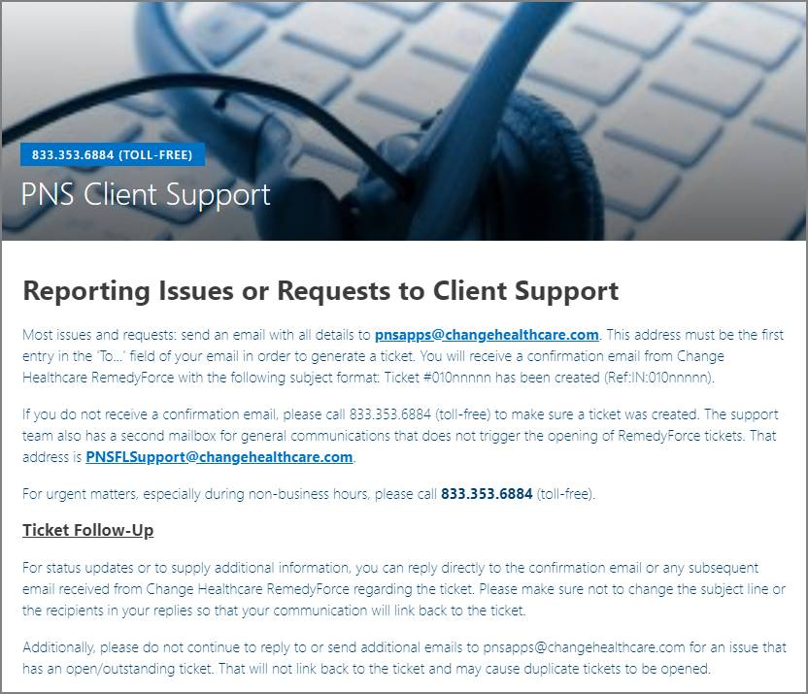

McKessen (cont.)

Use the on-call phone above for McKesson. The below numbers are old contact info.

- John MacKinnon, First
  - PH: John MacKinnon: (850) 543.3491, (850) 508-5876, (850) 208.3407
- Earl Page, Second
  - PH: Earl Page: (850) 417.8907
- Kelly Holland, Third
  - PH: Kelly Holland: (850) 208.3371

